CIS1513_Database Design
Using Oracle at Home
Step 1:

Copy ORACLEXE.exe to your jumpdrive or harddrive
From: I:\Instructor\BIT-ELAB\BJUDD\CIS1513\work_at_home

Step 2:
Run the OracleXE.exe file, it will show you the screen below: Click NEXT
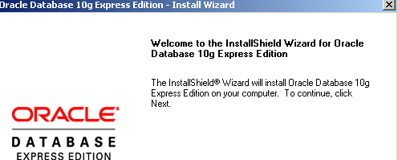

This will be the next screen you will use: Accept the license agreement
Click on NEXT
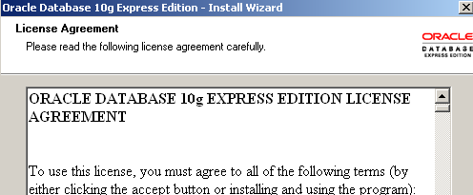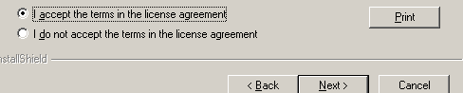

The next screen shows where it will install the program CLICK NEXT
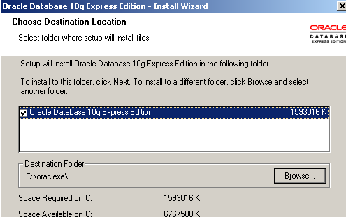

This is the next screen you will see, put in a password for the
USER SYS,SYSTEM key in: oracle and click NEXT
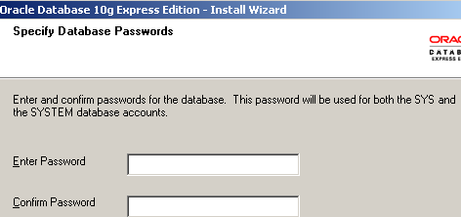
oracle
oracle

Click on INSTALL – It will then begin installing the software on your PC
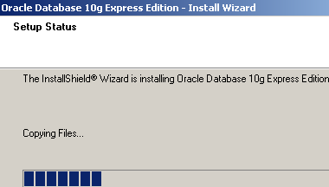
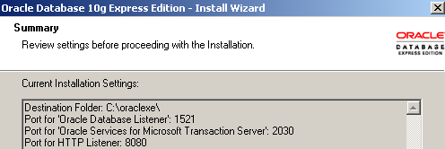
Step 3:
After the install, go to Start→ programs→ OracleXE → choose
Getting Started – Follow the 1st three steps
The steps will tell you to log on as System see example below.

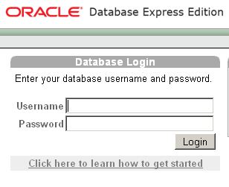
After logging in as System – you will see this window below click on Administration
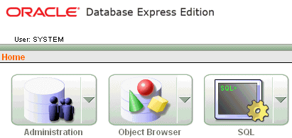
system
oracle

Then Click on Database USERS
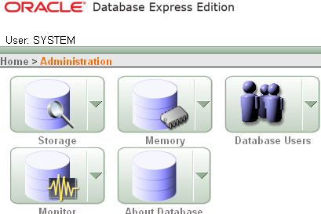

Click on the user: HR
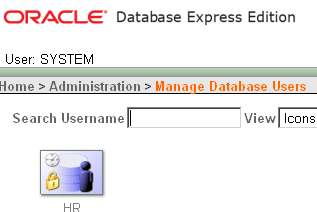
KEY in a PASSWORD for HR: Key in: oracle
Click on Account Status and change it to: UNLOCKED
CLICK on ALTER USER
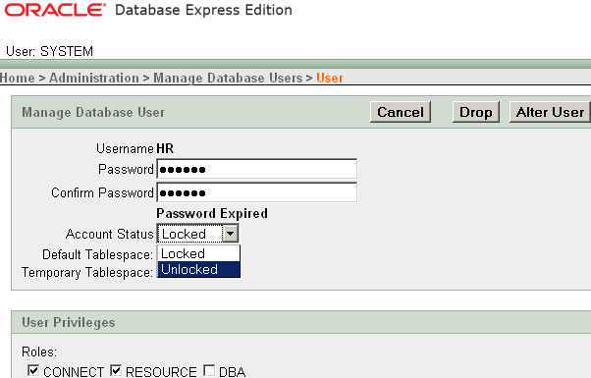
oracle

You should see this screen telling you the Password was changed and the user altered.
LOGOUT as SYSTEM

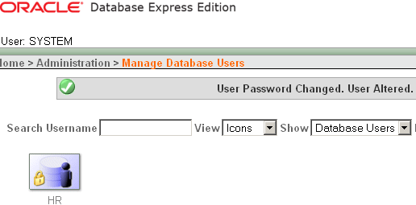



RELOG on as HR
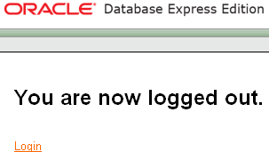

hr

oracle

This is the screen you will see after you log back in as HR (hr – is your username at home)
CLICK on the SQL window
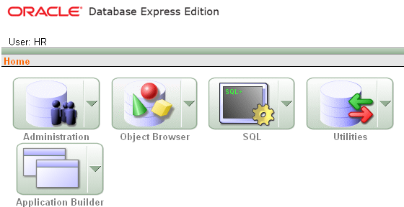

After you click on SQL icon above, you will see this menu, Click on SQL again.

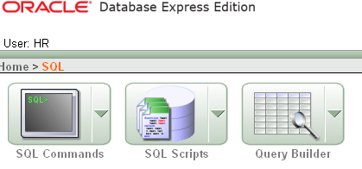
This is the next screen is where you will key in your create table commands. Click on Run

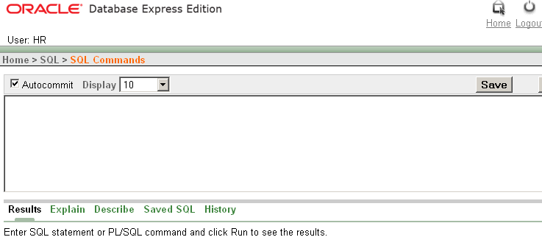
This environment is not programmer friendly, it is sometimes slower because there is a lot of JAVA behind the scenes to make it GUI . I prefer to use SQL DEV the method on the next page . (You still will use Oracle Express, as your server to connect to with SQLDEV)

USING SQLDEVELOPER – Programmer’s TOOL (Preferred method used at CNM)

STEP 1:
You must have installed Oraclexe.exe – before using this software and followed the instructions to unlock the HR user account.

STEP 2:
Make sure you copied the zipped folder called SQLDEVELOPER from the Blackboard module called: Installing Oracle at HOME, and it’s unzipped.
Open the folder after you have unzipped it. Look for SQLDEVELOPER.exe
- Launch the sqldeveloper.exe from the SQLDEVELOPER folder.
- Open Oracle Developer and CLICK on green +
Note: If you can’t see the green + , you might have to open the program as Administrator
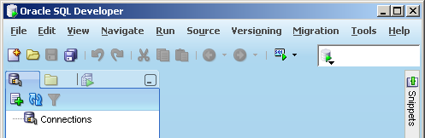

This is the next screen you should see: fill in the blanks with:
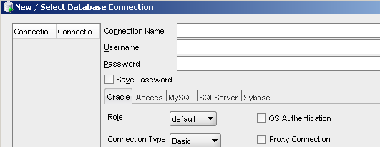
yourlastname_xe_conn
hr
oracle

Note: Leave HOSTNAME to localhost (at home)
Leave XE for SID

CLICK on TEST, then SAVE then CONNECT-if your connection was good status=success
Saving your CONNECTION String in Oracle Developer – after you get connected, then
Right mouse on: Connections - choose Export Connections
You will see the prompt below:
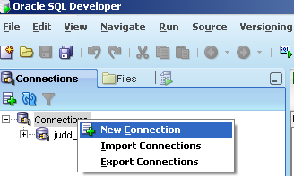

Key in your lastname_xe_conn Click on Browse and decide where the file will live
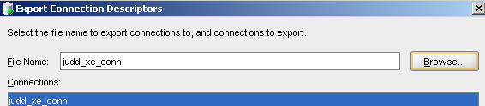

For FILENAME: Key in your lastname_xe_conn Click on SAVE
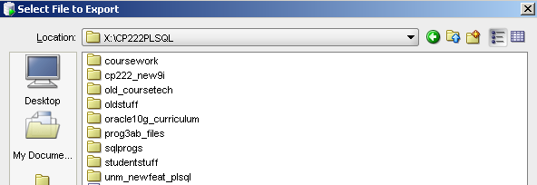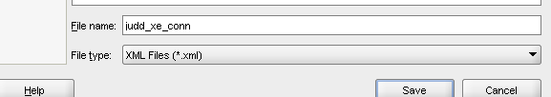
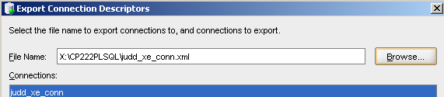
CLICK OK

You should see a message saying that it has been exported

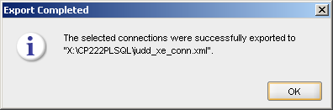

The next time you bring up Oracle Developer you will IMPORT the connection in:
RIGHT mouse on CONNECTIONS – choose IMPORT
The file will have an .xml extension. Click on Browse – go locate where you saved it.
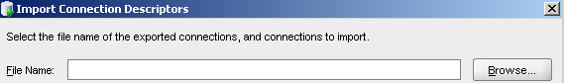
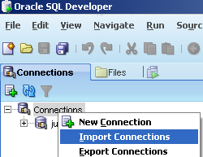

You should now be connected and be able to start keying in and running your SQL code.

Enter your SQL command- for example –
